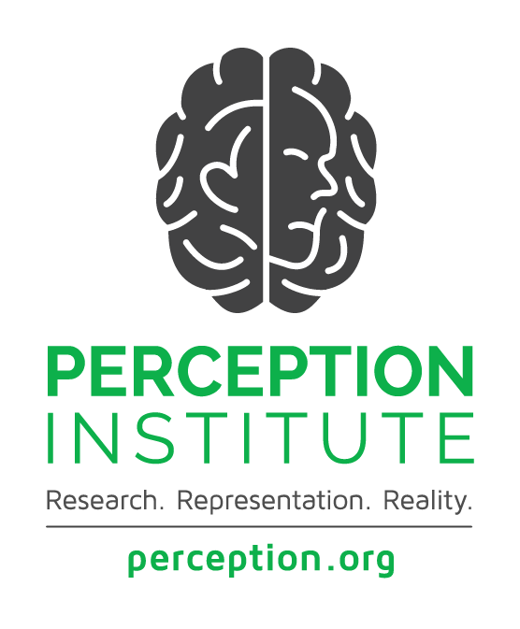

MIND SCIENCES KEY CONCEPTS

**Key Terms**

**Race:** a social construct that categorizes people in ways to maintain social status and hierarchy. The contemporary racial categories “white,” “black,” “Asian,” and “Native American” are based upon divisions that originated in the 17th century.

**Ethnicity:** a population group whose members identify with each other on the basis of common nationality or shared cultural traditions.

**Racial Identity**: a sense of group or collective identity based on one's *perception* that [he/she/they] shares a common racial heritage with a particular racial group (Helms, 1990).

**People of color:** primarily used in the US to describe any person who is not white. Preferable to “minorities,” which may or may not be accurate in any given place or time. The term encompasses all non-white people, emphasizing common experiences of systemic racism.

**White people:** a racial classification specifier, used for people of European ancestry.

*We recognize the limitations of language. We acknowledge that racial and ethnic identities often overlap and that some people may have multiple identities or identify differently than the people of color/white binary.*

**Phenomena Linked to Race, Ethnicity, and other Identity Categories**

**Implicit Bias:** the brain’s automatic, instant association of stereotypes or attitudes toward particular groups, without our conscious awareness.

* The split-second decisions our brains make (e.g. reactions to or assumptions about someone) without our realizing it.

**Racial anxiety:** the brain’s stress response before or during inter-racial interactions.

* For people of color, racial anxiety is often the fear they will experience bias from someone else, through discrimination, hostile treatment, or invalidation.
* For white people, racial anxiety is often the fear their actions will be perceived as racist, or that they will be met with distrust or hostility.

**Stereotype threat:** the brain’s impaired cognitive functioning when a negative stereotype about ourselves is activated, leading to underperformance on a task.

**Microaggressions**: brief, everyday exchanges that send denigrating messages to certain individuals because of their group membership (Sue, 2010).